Quality Attribute Scenarios

# Internal

## Modifiability

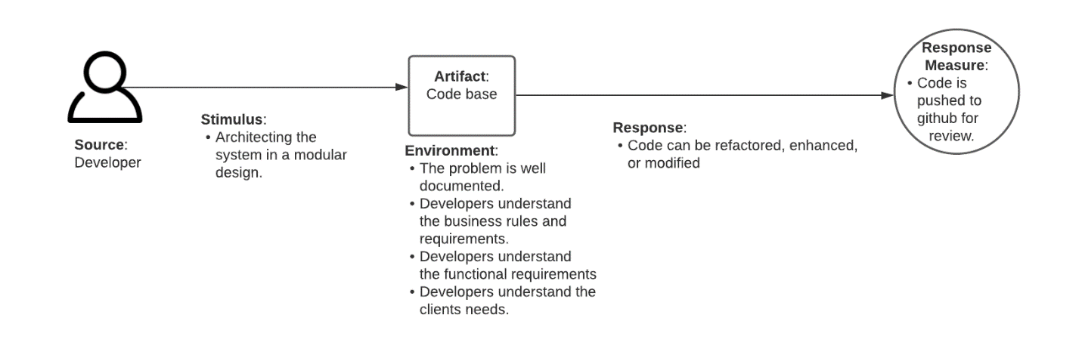

## Reusability

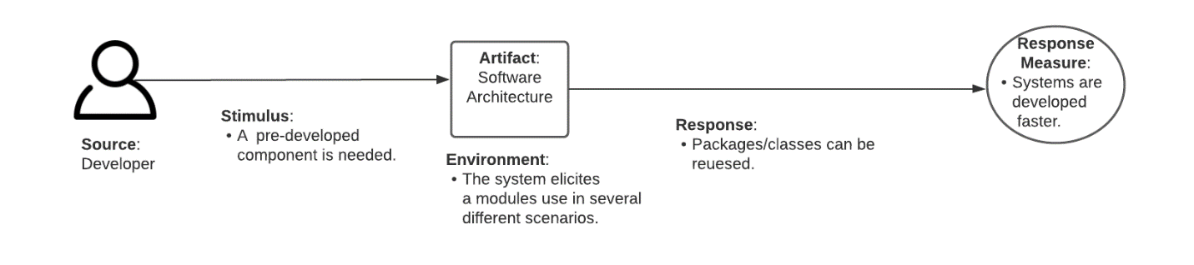

## Verifiability

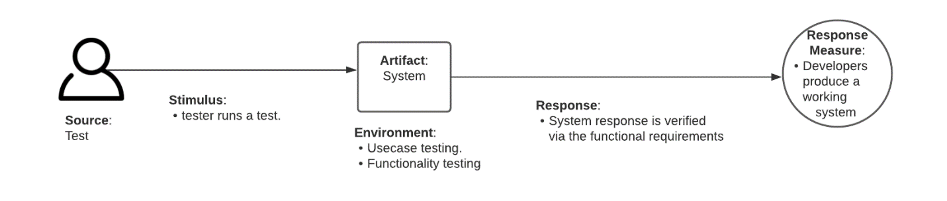

# External

## Integrity

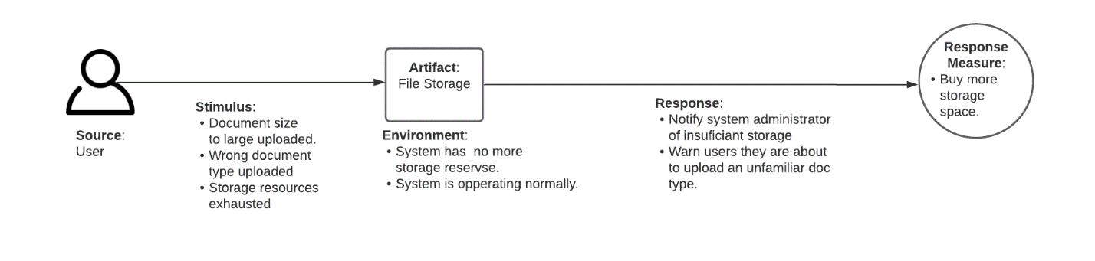

## Usability

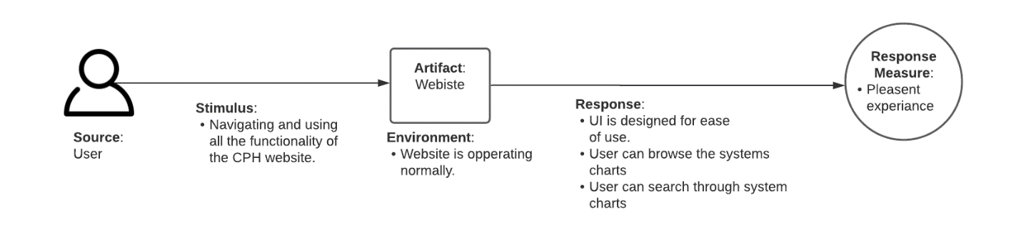

## Installability

